



*Business Plan*

*Viability of Business Projects*

**Project Group:**

Andrea Armani

Ricardo Holthausen

Jesús Huete

Adrian Manco

Dimitrios Tsesmelis

**Professor(s):**

Marcos Eguiguren Huerta

**Project Period:**

Winter Semester 2020

**Date of Submission:**

June 15th, 2020

Edifici B6 del Campus Nord, C/Jordi Girona, 1-3, 08034 Barcelona

*The content of this report is freely available, but publication (with reference) may only be pursued due to agreement with the authors.*

**Introduction, Sector, Company and Products** **5**

Sector, company, products to commercialize 5

SWOT and Porter Analysis 6

SWOT Analysis 6

Strengths 6

Weaknesses 7

Opportunities 7

Threats 8

Porter Analysis 9

Threat of new entrants 9

Threat of substitution 10

Suppliers 11

Customers 12

Competitive rivalry 13

Competitive Advantages 13

Mission, strategy, viability 13

**Market research and Analysis** **15**

Potential customers 15

Market size and tendencies 16

Existing competitors 17

Sales prediction 18

**Marketing plan** **20**

Segmentation, Targeting and Positioning 20

Product 21

Price 22

Place 22

Promotion 24

**Design: Products and Operations Plan** **25**

Situation of product/service and expected problems 25

Future designs 26

Development budget per product line 27

Geographical location of the productive activities 27

Installations, description and technical features 28

Production strategy 28

Prototype 29

**Management Team and Staff Structure** **30**

Organization: chart and profiles 31

Key directors: profiles and CVs 32

Directors’ shares: Remuneration and Contribution 34

Board of directors 34

Professional support services to hire 34

**Business Project: Beginning Calendar** **35**

**Financial Plan** **36**

Profit and Loss Statement Forecast 36

Balances Sheet Forecast 39

Treasury Forecast 40

Break-even Analysis 42

Graphical representation of the Break Even point 43

Cost Control Management 44

**Business Plan: Potential Risks and Problems** **46**

**References** **48**

**Appendix A** **50**

Table 1 (Customer segmentation) 50

# Introduction, Sector, Company and Products

## Sector, company, products to commercialize

Freekick is a software that aims to fill the gap between football players and scouters from mid-size teams. It offers a new scouting process mainly based on the psychological characteristics, implemented through the usage of behavioural tests and social media analysis.

In the “Annual Review of Football Finance” Deloitte highlights how the football market increased from 19.4 to 25.5 billions of euros in the last 8 years, hence is safe to say that Freekick operates in a healthy market [1]. However, even though this growth continues year in year out, it happens with a different pace among big teams and medium-small ones: according to the “UEFA's Club Licensing Benchmarking Report” [2] in the last years this gap keeps increasing. In terms of scouting it follows that big teams can rely on experts from different fields to assess the value of a new player, while small and mid-size teams do not have sufficient resources to perform in-depth analysis.

Consequently, the majority of the football teams have to rely on available tools to integrate their scouting analysis.

At the moment, the scouting market offers different solutions to scout football players in a traditional way, which is based on physical ability and statistics about the player’s performance. However, none of them focus on exploiting Big Data technologies to enrich and perform a better analysis that could also consider the psychological and behavioral aspect of a player.

In such a context, Freekick is an innovative product built and designed to help mid-size and small teams to perform an in-depth scouting campaign, considering that a player is not only defined by his physical ability, but also by the psychological and behavioural aspects that define him as a person.

In order to succeed in this complex task, Freekick performs behavioural tests and analyzes social media contents from different platforms to assess several mental characteristics of the athlete, along with the traditional performance statistics in order to recommend players which fit the team’s needs.

In order to acquire market share, initially Freekick’s pricing will be aligned with the ones proposed by Wyscout, the major competitor in the market. However, once the platform has successfully established its position in the market, it will be possible to customize the offer in order to better tackle the customer’s needs.

## 

## SWOT and Porter Analysis

### SWOT Analysis

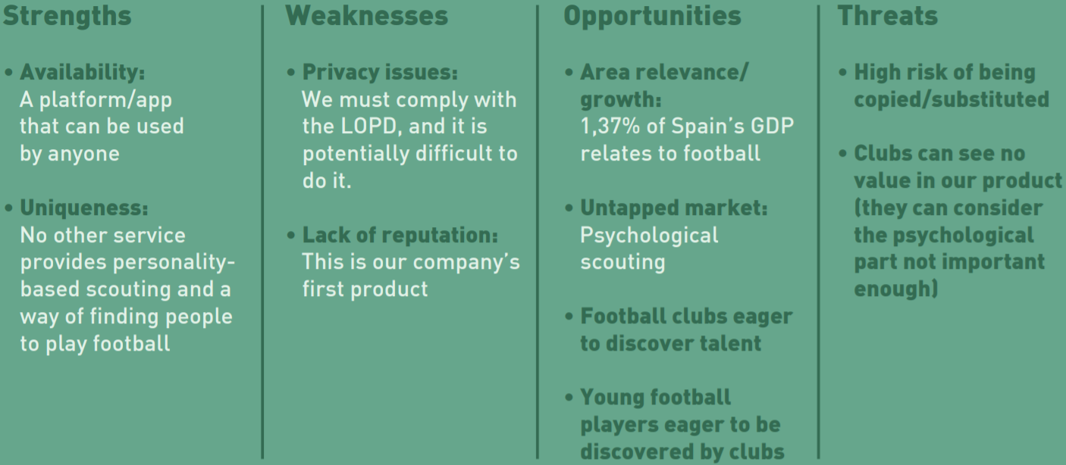

In this analysis SWOT stands for Strengths, Weaknesses, Opportunities and Threats. We decided to use this tool, because it was a convenient way of summarizing the status of our proposal with regards to these four dimensions, and because it served us as a way of reviewing the current state of our work, and to predict how we can advance in the future. In this section, we are going to go in deep into every part of the SWOT analysis we conducted, so we can have a complete overview of our situation.

#### Strengths

When analyzing our idea, we concluded that one of the key features that could make us stand out is the high Availability we offer. Not only in terms of geographical availability, but also in terms of who can actually use the app, and via what device. Besides the global availability that all internet and, more specifically, cloud-based solutions offer, the approach we took for the actual architecture of our solution made possible to have virtually the same app for both computers and mobile devices. With regards to the actual level of expertise needed to take the most profit out of the solution, we took into account that we are aiming mostly for mid or low level teams that might not have specialized, expert staff devoted to scouting. This way, it is more accessible for more modestly budgeted teams, and can make us reach our clients on a larger scale. Finally, and with the same ideas in our mind, we designed the visual aspects, as well as the workflow of our application intuitively enough, so the experience of getting started is frictionless and appealing.

Besides Availability, we believe that we have a strength in Uniqueness, too. The vast majority of scouting companies base their services in purely statistical, physical-based data, that takes into account only the performance of players at match time. As we explain when talking about the product and services we offer, our sight goes beyond, and we take into account also the psychological dimension of the individuals. This creates an added value that our competitors cannot provide, and gives us a chance to take a place in the market.

#### Weaknesses

After listing the features that can give us an edge in the market, it was also necessary to find the points where we can find flaws in our proposal. The first potential issue we found is related to Privacy. Although it is true that we do not take any data that the user is not willing to share, when it is time to perform our psychological analysis, we have to be sure that we comply with data protection laws. Otherwise, we could face serious fines, that might be a problem when we are first starting.

Other than that, we are also concerned about the lack of reputation of our company. We are trying to make ourselves a place in a market crowded with companies already successful and popular. Because of our novelty, we have the problem of convincing potential companies of our worth, and also having to persuade them to leave their current habits to give us a chance. For these reasons, we think that as we step into the market, we are going to find some difficulties more related to the already existing habits and tendencies of our potential customers.

#### Opportunities

When analyzing possible entry points in the market, it was essential to see the state of the market with regards to the field in which we make business. We started on the football market in Spain, and saw that a noticeable percentage of its GDP came from it. Since football is the most popular competitive sport in most of the countries, it made us think that, if the market was so powerful in Spain, it is easy to expect a similar behaviour in other countries, be it in Europe, or worldwide. Furthermore, if the GDP that football represents in each country is somehow similar, the money it moves in even richer countries makes the business potentially profitable, and thus worth the effort.

Besides the profitability and importance of the sports market worldwide, there is an untapped business that remains virtually unexploited, which is psychological scouting. As we mentioned in the Strengths section of the SWOT analysis, we believe that the psychological dimension of our proposal can give us an edge in the market, but it can even consist of a market on its own. If we manage to succeed in our efforts to establish this kind of scouting, we could be pioneering an unexplored territory. It would not only set us in a vantage point with respect to later competitors, but increase the awareness of our company and product as successful and innovative, which is key in the long term.

To conclude the exposition of our opportunities, we have a two-faced concept. On one hand, we have that clubs are always eager to include good players into their teams, since it is a way to increase the competitiveness of their own club, and it makes it easier to win matches, competitions, earn more money, and eventually grow to become a greater and more recognised club. Clubs may also be interested in investing in promising individuals, so they can train them, and start getting the benefits from a good player as soon as possible. In this sense, we can conclude that the demand for the product we offer is not expected to drop, and thus our continuity in the business is guaranteed.

On the other hand, we have players that want to be in a club. It doesn’t matter if it is a promising player looking for someone to give him/her a chance, or an experienced player that wants to change team. Our solution will allow players to increase club awareness about them, and make them able to promote themselves, in search of good clubs. This allows for a faster spreading of our solution, since players with a good experience on it will share their feelings with other colleagues, and will save us from doing bigger promotion campaigns. This doesn’t mean we will forget about promotion, but by making players able to actively participate in the workflow of the solution, we expect it to be more fluid, and to grow faster in popularity.

#### Threats

Lastly, we have the dangerous aspects of our proposal: the threats. The first threat we considered was that companies already present can see the potential in our approach, and implement it on their products. Since chances are that they have more staff, resources and popularity, they are likely to have a working solution that includes our philosophy before we can make ourselves strong in the market. This can be a great obstacle in the life of our company, unless we manage to make our product so recognisable that other companies can’t steal our ideas. This threat aligns with the mentioned weakness of being a new company in a very competent market. To avoid the harmful effects of being copied or substituted, we need to plan our go-to market strategy carefully.

As a threat, we have a fact that is very present in every novel approach or idea, and that is the fact that the people taking the benefits, actually struggle to believe it is going to work. Scouting based purely on statistics is a very solid and proven technique, so people can be reluctant to move from something that has proved mostly useful for so many years. We obtained our first insights on this after conducting our first interviews. The general feel was that, even if psychological profiling was indeed useful, they needed to get some statistical data, too. It makes sense to see psychological profiles as a complement of statistical results, and not as a standalone service. In the end, clubs need to win matches, and that is achieved first of all by a good physical performance. Our hope, then, is that our clients are able to see the value in having that additional information supporting the more classical scouting approach. For this reason, we offer the traditional scouting features everyone would expect, as well as our original approach to it.

### 

### Porter Analysis

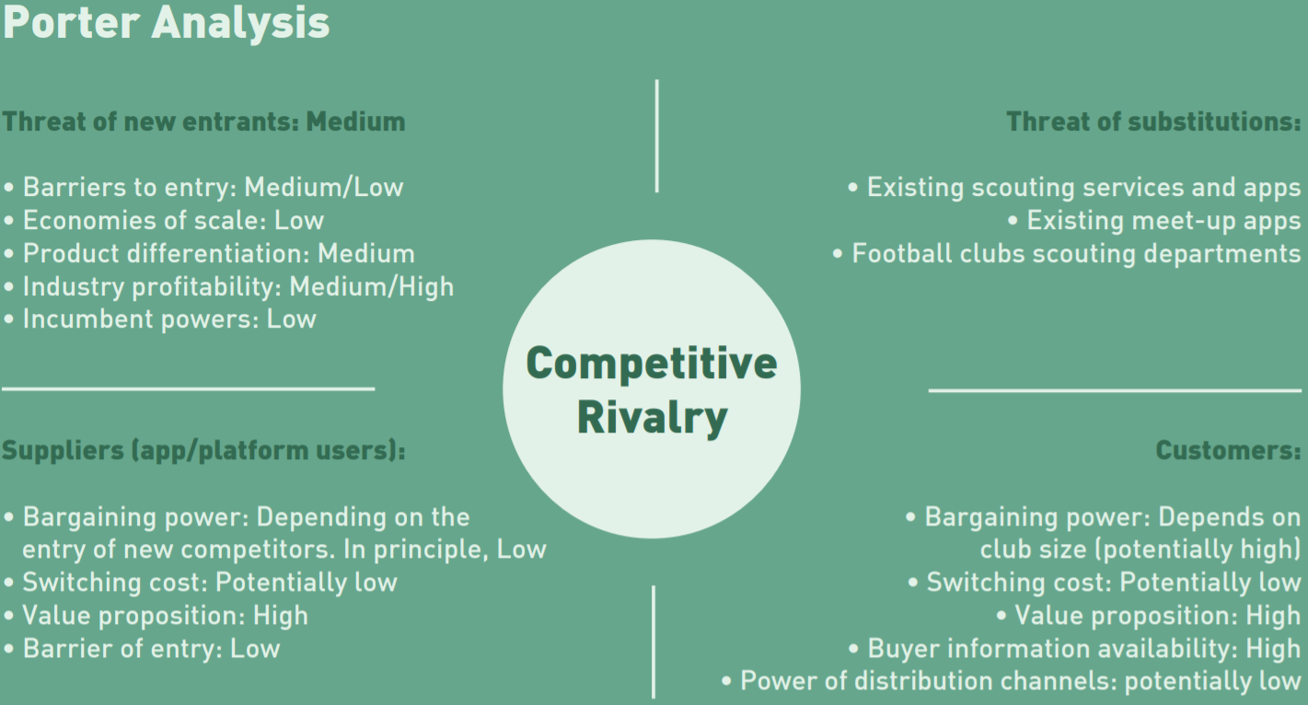

To make our preliminary study of both our company and the market, we needed to find a tool that was able to assess the worth of the latter. For this, we decided to use Porter’s Five Force Analysis. In it, we could observe how intense each of the powers was in the context, and thus see how attractive in terms of profitability was the industry we wanted to make business on. In this section, we will list the Five Forces treated in this analysis, see how they affect our project, and expose our conclusions about them with regards to our interests.

#### Threat of new entrants

If we have seen the potential profit of the scouting industry, chances are that more people will see it in the future. Furthermore, we are newcomers in the market, and as such, we are a threat for companies already operating there, since we aim to get a share of the overall business by taking away from our competitors a certain percentage of the customers. If we are to imagine that we are already operating in the market, we can assume that the threat of new competitors is not very high, because unless they have a really innovative idea, like we do, it is not very appealing to enter the scouting market just offering the same services as many others companies are offering. More specifically, we have the following conclusions:

* **Barriers to entry: Low to Medium**
  + In this particular market, there is not a main incumbent on monopoly. This allows any new company to enter the market, and try to make itself a place there.
* **Economies of scale: Low**
  + In this market, the main products are services, meaning that we are going to find virtually no production cost that can make us rethink the scale of our operations. Even if the scope of our operations was limited somehow by the hardware resources we own, nowadays services like the cloud can offer a really affordable scaling, that will adapt to our needs. In that sense, we can conclude that in this market the scope of operations is mainly limited by marketing and strategic decisions, rather than production cost-related ones.
* **Product differentiation: Medium**
  + Although it is true that we believe our approach to scouting is unique, to make our service more complete, and the user experience frictionless, we needed to include more traditional features in our proposal. For this reason, our product can lose part of the differentiation that it might have had, if our set of functionalities was completely innovative and disjoint from the rest of the products in the market. We believe this is not a reason to think that our product is just like any other one in the market, but it is possible that we do not manage to differentiate ourselves strongly enough to the eyes of the public, if we do not enforce a clever enough product design and marketing strategy.
* **Industry profitability: Medium to high**
  + After doing market research, we concluded that the football industry is responsible for a relatively high percentage of the GDP of some countries. This, along with the fact that football has very deep social roots in those countries, makes us think that we are talking about a solid industry that is unlikely to disappear in the short to mid-term. Furthermore, we have seen how the football industry has been moving more money each time from several decades until now. The increasing trend in the profitability of this market makes it easier to have a fair income even if having a relatively low share of the sales, but also increases its appeal, as we reflect in our analysis.
* **Incumbent powers: Low**
  + In other markets, like the telephonic one, there are some major companies that own the infrastructure, and force newcomers to depend on them, unless they are willing to make a huge investment in new communications equipment. In the scouting market, there are certainly some very influential entities, but none of them are owners of any sort of infrastructure or exclusive rights. Hence, newcomers do not depend on them, and the only problem they will face is actually being competent enough to be able to take a share of the market.

#### Threat of substitution

In our case, our approach serves as a shield against substitutes. The most obvious approach to scouting is to leave the psychological part unused, and hence we can expect that, unless the awareness of our firm is rapidly increased, the possibilities of more companies copying us in the short term is rather low. An actual substitution for our product has to take into consideration at least the same information we handle, so as long as other newcomers do not focus on psychological scouting, we have a relatively secure position in the market.

Other risks are related with football teams creating scouting teams of their own, and thus not needing our services.This is an important problem for the case of top level teams that still do not have their own scouts, but since we are focusing our target on low to mid budget clubs, we do not expect this to be an actual problem. It is safe to think that, for them, it is more cost-effective to invest in our services, rather than building their own infrastructure.

Lastly, assuming that a number of clubs adopt us as their prefered scouting option, if we manage to be successful in our mission, there would be no reason for them to switch to other firms, since they would lose the added value of psychological profiling. Taking into account the reasons exposed, we can conclude that unless other companies include innovative features different from ours, or we fail in our mission, the threat of being substituted is relatively low for our company.

#### Suppliers

In essence, we are building a platform so we are able to offer our services. In our case, we do not need raw materials, nor machinery. The only mandatory source of input to fulfill our mission is the data from the players. As long as we can keep obtaining data, we will be able to track the performance of players, as well as conducting our psychological profilings. For our case, the bargaining power of our data sources is limited, since they only have the power to grant us permission to access data, and to revoke it at any time. The rest of the whole scouting process depends on their own performance, personality, and the interest of other clubs in them. Next, we can find more in depth considerations:

* **Switching costs: Potentially Low**
  + Since the only effort we require from the user is its permission to collect performance data, and to conduct a psychological profiling, we expect that the effort to start using our solution is almost null. In case they are new in the whole scouting context, the experience of entering should be frictionless. If, on the other hand, they are already using another scouting solution, it is easy to expect that they want to increase the awareness of their persona, so they should be eager to be on many scouting platforms simultaneously. For players, it is a matter of being in as many places as possible, so they maximize the chances of finding clubs interested in them.
* **Value proposition: High**
  + For our suppliers, that are the players, the value proposition is huge. We are offering them to be present in an innovative platform that aims to change the scouting paradigm. For humble teams, the chance of having scouting services at an affordable cost is very appealing, while, for their players, having the chance of being noticed by larger clubs is a great opportunity. In the end, we are offering services to collectives that otherwise would need to do a high and very risky inversion, so we expect that the value proposition we are making them is high enough to give our product a try.
* **Barrier of entry: Low**
  + As stated, unless clubs have their own scout staff, or decide that they do not need our services, there is virtually no major obstacle for using the platform and start seeing the benefits. The only barriers could be the lack of money to pay for our services, or that they already have a contractual compromise with some other scouting agency or service. Another relevant matter are the clubs that have a great amount of junior players, whose data must be protected with special care. In that case, clubs could find that the players in which they are interested are too young to be tracked, and hence decide that it is not worth using our services.

#### Customers

In our case, our customers are particular agents or scouting staff of football teams. With regards to the bargaining power they have, we believe that it is relatively low, because we intend to adjust our prices to something really feasible, and since our approach is really unique, there is no other equivalent product in the market. Then we could say that, unless there are complaints about functionality issues, or data protection problems, there is not much margin for customers to force us into changing our business direction. Here we discuss some relevant aspects:

* **Switching cost: Low**
  + We expect that the cost of moving our solution is low, because we offer an innovative approach, and competitive prices. At first, customers may see us as a complementary scouting tool, but we aim to be effective enough so they choose us exclusively over the other options available in the market.
* **Value proposition: High**
  + We are making a huge value proposition to our customers, since we are offering a complete scouting tool, that contains some exciting new features, and at reasonable prices.
* **Buyer information availability: High**
  + Our customers will have at hand every information they might need. No matter if it is about the profiling techniques they use, or how the data collected is used. We aim to be as transparent as possible in times where data leakage is a common fact. For us, the business is in fulfilling our mission, and being able to build ourselves a name in the industry, so we can stand out among the rest of scouting companies.
* **Power of distribution channels: Low**
  + Since we are offering a digital service, we are virtually independent of distribution channels. Of course, we have a certain dependence on the communications infrastructure, but unless in a certain country the access to internet is not feasible, we expect no further problems. In case of using cloud services, we would effectively increase our dependence on distribution agents, but nowadays this shouldn’t be a problem, since we can change providers with a relatively low effort if the need arises.

#### 

#### Competitive rivalry

We expect quite high rivalry from the rest of the companies. This market is very big, and moves great amounts of money, so we expect fierce competitiveness, especially when first starting. The innovative approach we follow with regards to the profiling of players can make other companies question our ethics and hidden agendas, and thus damage our image in the eyes of potential customers.

Taking into account there are already a number of powerful firms in the scouting industry, we will need to try our best to get our share of the market. This forces us to constantly check the pricings and features our opponents are offering, so we can adapt our own and keep the competitiveness high.

## Competitive Advantages

Although the sector of sport scouting is well-known, and already has some noticeable entities, when first ideating our company and product, we managed to find some key features that might give us an advantage, when compared to the rest of companies in the sector.

The most common approach is also the most obvious one: if we want to scout, for example, football players, we will track them, and see how they perform in a physical, results-focused manner. This is valid, since in the end clubs need individuals that will grant a certain level of sports excellence, however this approach has a flaw that can prove fatal: it ignores the psychological dimension of players.

It is easy to remember a promising football star that, during the first years of its career, offers a high performance, but as the time passes, it gets lower, until it is seen as a failed promise, or get involved in problems outside of the sports field. To try to avoid this, we propose to take into consideration physical statistics, as well as psychological profiling, so clubs have a broader perception of the individual, before they decide to invest their money.

Because of its novelty, our approach can give us an edge when competing with other companies, and if it proves useful, it could even position us as the new paradigm of sports scouting. Traditionally, the athlete has defined the person. We aim to change this statement. With our approach, **it is the person who defines the athlete**.

## Mission, strategy, viability

Freekick strives to place itself as the best go-to scouting tool, providing the most extensive scouting experience at the fairest price in the market.

In order to live up to such a goal, Freekick defined a strategy to attract a market segment and establish itself in the upcoming years.

Several events related to the football industry are organized during the year. Such meetups are fundamental opportunities to promote Freekick and the innovation it brings to the market. Among the events, Freekick is especially interested in attending:

* **Soccerex**: started in the early 2000s , Soccerex is an event that has been bringing together the global football industry to network in a unique commercial environment for over twenty years. Soccerex provides a platform to connect businesses with the game's key stakeholders;
* **WFS - World Football Summit**: started in 2016, WFS provides a platform and a voice for all stakeholders involved, allowing them to meet, discuss, promote and generate business opportunities amongst each other;
* **ISC - International Sport Convention**: started in 2009, ISC is a B2B event that provides one of the best networking and delegate experience in the sports industry. ISC is not solely related to football, instead different sports are hosted there. ISC hosts sports business content, with around 150 speakers and approximately 1500 delegates per edition.

However, minor events have to be attended as well, in order to gain recognition among investors.

The consensus among young athletes is fundamental for Freekick: the scouting strategy is based on their participation in the app. Therefore, Freekick will develop a marketing campaign mainly hosted in the most popular social media (Facebook, Twitter, Instagram, etc.) and based on the sponsorship of young football influencers.

In a first step, Freekick will collaborate with different influencers across the globe with a small network of contacts. In such a way, the investment for the campaign is reduced, while different communities around the world start to appreciate the tool. In a further step, Freekick will start sponsoring footballers that previously registered to the platform and were scouted from a football team. These sponsorships are intended to provide a testimony about the successful approach Freekick offers to companies. Finally, the company will regularly control the post streaming and will measure how the buzz increases around Freekick.

The costs to realize and manage Freekick software are shrunken down thanks to Cloud Computing technologies that nowadays allow to build, deploy and maintain a business without purchasing hardware and software infrastructures. Furthermore, using such technologies allow us to automatically scale up the business, once it starts to take off. Hence, the risk inherent to the initial business expenses can be controlled as much as possible.

Although reaching several customers and users requires some time, considering the rich industry in which the company operates and the substantial lack of a big number of competitors, Freekick has the possibility to become a profitable project in a reasonably short period of time. Further analysis on this statement can be found in the next chapter.

# Market research and Analysis

## Potential customers

Customer segmentation is the process of dividing customers into groups based on common characteristics in such a way that companies can approach each group more effectively and appropriately. The idea behind the customer segmentation is that not all the people are thinking and acting in the same way and obviously they do not always share the same motives. Something similar happens when it comes to clients targeting, which is a determinant factor for the companies, as the more clients a company has, the bigger revenue it gets.

For this reason, Freekick is giving great importance to customer segmentation. Specifically, after around three months of market research, we ended up with the two following splitting factors for our clients.

1. The first factor is related to the **gender** of the players of the teams. It is obvious that we need to differentiate the way you are treating the teams based on whether they want to scout for men or women. They basically consist of two completely different markets with different standards, needs and philosophy. A typical example of this is the available data that exists on-line. On the one hand, there is plenty of data available when it comes to men’s football, both open source and private. On the other hand, women’s football is lacking data, as its audience is much smaller. This makes us believe that the way we should approach these two markets is completely different.
2. The second and maybe most important factor is the **market value** of the teams. Market value is the price an asset would fetch in the marketplace, or the value that the investment community gives to a particular equity or business [3]. The market value is mainly affected by three factors.
   1. **Risk** **sensitivity**: Lower risk for high values. Regarding our domain, a well known and high-performance team is not very likely to attract and buy moderate and bad players, because it can afford to buy the “elite”. Also, the risk of “failure” is considerably lower, because buying a moderate player will not be determinant for the team's economic growth or well-being. For instance, given that Barcelona and Girona buy the same moderate player, the impact will be much different.
   2. **Growth**: High growth (in terms of revenues, assets, performance, division etc.).
   3. **Quality of growth:** Long term growth and sustainability (e.g. brand name, quality of players). For example, a team buying the best player in the world, who will retire in 1,5 years, is not a long-term growth move.

To understand the importance of market value we can think of the following intuitive cases. A High market value team can buy an “expensive” player with lower risk, who can provide growth & quality of growth. At the same time, buying a “cheap” player (moderate one) is low risk but zero growth. That is not the case for a smaller team (really high risk & potential growth). For instance, a smaller team would buy an older (but still good) player (smaller market value) in order to ensure growth (not quality of growth) and minimize risk. A moderate team will have a moderate risk by buying an expensive player and a great potential for growth and quality of growth.

To ensure that our customer segmentation is valid, we made our analysis based on real data that we extracted from a trustworthy source [4]. We need to note here that the collected data is a sample of the complete dataset, however it is a reliable sample as it includes teams that are members of the Union of European Football Associations (UEFA) and we tried to keep a realistic balance between the amount of teams of the different segments. The created segments based on the market value are the following:

* Segment 0: 600m-1bl
* Segment 1: 400m-600m
* Segment 2: 250m-400m
* Segment 3: 150m-250m
* Segment 4: 50m-150m
* Segment 5: <50m

In Table 1 of Appendix A there is the data we used to create the segments.

## Market size and tendencies

Football is one of the most profitable businesses worldwide considering that the annual budget of several teams can exceed billions. In addition to that, there are extremely a lot of football clubs all over the world. Only in Great Britain, there are 5300 teams affiliated to the Football Association and 26000 football clubs in Germany. These two things make us believe that the whole football market is huge, and it is sure that it is impossible for a startup to target the entire market.

Freekick is basically focusing on two main categories of teams. Firstly, we are interested in selling our services to teams that belong to the UEFA. UEFA includes almost all European football teams as well as transcontinental states (Azerbaijan, Georgia, Kazakhstan, Russia and Turkey) and others that are considered part of Europe both culturally and politically (Armenia and Cyprus). Moreover, we are not focusing on teams that belong to either Segment 0 or 1 (market value greater than 400 millions). The reason why we took this decision is because teams with very high budgets probably have their own scouting department that is analyzing and developing more advanced scouting techniques than the usual one. Hence, the scouting approaches of such teams may have common traits with our product which is something that will discourage them to cooperate with us.

In the next chart, we can see a visual representation of the market value of some of the teams that exist in Table 1 of Appendix A. On axis x there are the teams, sorted by the market value in descending order while on axis y there is their corresponding market value. In addition, there are depicted the different segments that we are interested in as well as two of the teams that we managed to make interviews with and they were interested in our product, namely Norwich City (England, Premier League) and Aris Thesalonikis (Greece, Super League).

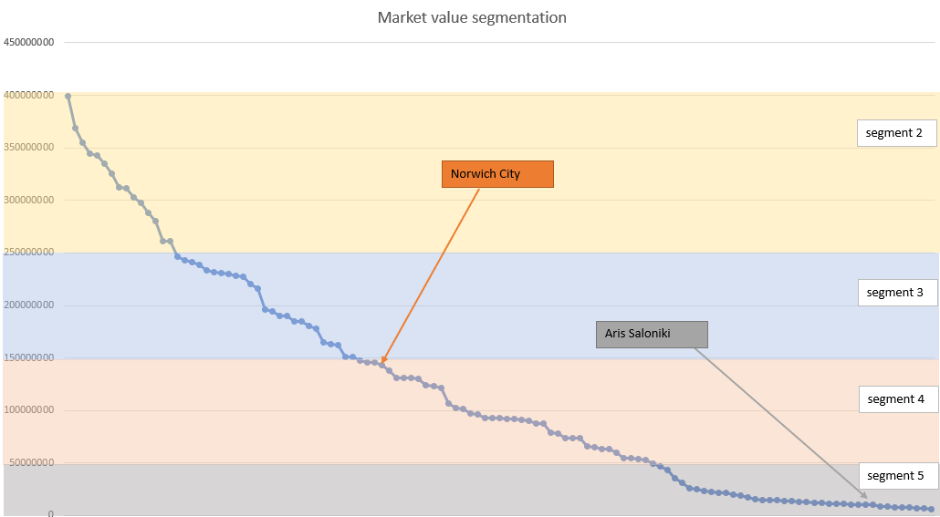

## Existing competitors

One of the most relevant competitors we found is Wyscout [5]. They define themselves as “The Football Platform”, and claim to offer “The professional platform for people working in the football world”. They have different products, tailored for professionals or organizations, and also provide APIs, so users can programmatically extract data. From our interviews with the football teams, we realized that most of the teams are using Wyscout’s videos in order to track the performance of the athletes during the matches. Their main product is around video frames of football players, as they are editing many of the previously played matches, they extract the frames that are interesting for the teams and they present them on their platform. This helps scouters to see how a player of their interest is acting without being necessary to go and watch him in real time.

By observing them, we concluded that, if we are to succeed, we have to be very complete in our offering, and give users the feel that they are working with a professional tool, that actually can make a difference in their daily job. Since they focus on statistical and video-based data, they offer a huge set of features designed to take the most of such sources. They also offer forums, so the users can communicate with each other, and the company staff can answer doubts and make suggestions.

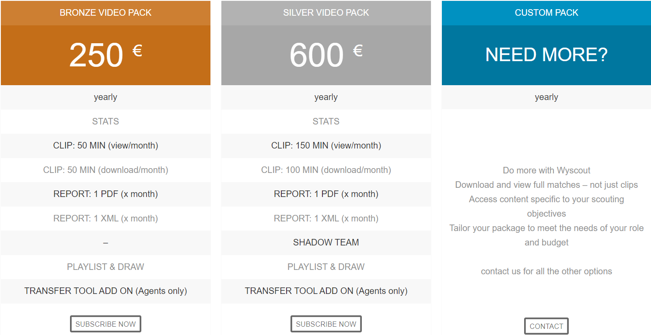

Source[6]: Wyscout Pricing System

With regards to pricing, they include two tiers, with some differences. As said previously, this platform relies heavily on video, so one of the improvements from one tier to the other, is the amount of video that can be consumed. In the Custom Pack, Wyscout will negotiate the price and options included with the interested user.

Another competitor that was mentioned several times from the teams that we got in contact with is Instat Scout [7]. Instat Scout is a digital platform with videos, statistics and interactive charts. They provide information on over 960,000 players from all over the world. The competitive advantage is the quality of statistics that they provide and that is the main reason that football scouters use this platform.

As we know, football scouting is a very wide domain and it is logical that there are a lot of competitors. However, it is worth mentioning that out of all the interviews we did with the football teams, we conclude that what is really missing right now from the scouting tools, apart from the psychological information that is not yet implemented by anyone, is a centralized platform where a scouter can get all the information he needs, without going from one source to another. Most of the people that we talked with, agree that despite the fact that our competitors are continuously trying to integrated all the required data in their platforms (e.g. statistics, videos, reports etc.), scouters tend to use different tools for each task they want to conduct, as each platform specializes in a specific domain. This fact persuades us to focus on the behavioral side of the players and create a complete platform that will serve this specific need of the teams.

## Sales prediction

In the Market size and tendencies chapter we mentioned that we are mainly targeting teams that are members of UEFA and members of UEFA is considered every team that participates in at least one UEFA competition. Taking that into account, there are thousands of teams that are potential customers, including Men’s and Women’s football teams as well as teams of under 21, under 19 years old and national teams.

To make an estimation of the initial number of our clients, we need to take into account the number of teams that find our product attractive and the strategy that we followed to approach teams.

Regarding the latter, during this initial phase, we spent around 2 months to make interviews, receive feedback from the market and investigate further needs. The main communication channels that we used to reach out to teams were direct emails and messages via LinkedIn. Specifically, most of the teams were finally contacted through the second channel. A thing that helped us a lot in this effort was to find the right persons to contact, as it is significantly different contacting the lead scouter of a team than the doctor. Finally, another thing that we need to consider is that during our market research, the COVID-19 pandemic severely affected the sports market, and especially the football, as all the matches were cancelled and the teams lost a big amount of income. As a result, we managed to interview three football clubs, namely Norwich City FC, Aris Thesalonikis FC and Women’s U19 Greek National Team, who found our product very useful and innovative and they would definitely buy a package of our services.

The above mentioned factors make us believe that with the right marketing strategy, an appealing price policy and an appropriate advertisement, we will achieve to sell our product to around **100** football clubs **during the first year**. By further promoting our services and adding new features, we firmly believe that in the next few years this number will skyrocket and most of the clubs will be using our platform to enhance their scouting experience.

# 

# Marketing plan

## Segmentation, Targeting and Positioning

As previously explained, in our market analysis every team belongs to a segment based on its market value:

* Segment 0: 600m-1bl
* Segment 1: 400m-600m
* Segment 2: 250m-400m
* Segment 3: 150m-250m
* Segment 4: 50m-150m
* Segment 5: <50m

Such segmentation is shown in the following chart. As mentioned before, the visual representation depicts some of the teams that exist in Table 1 of Appendix A. On axis x there are the teams, sorted by the market value in descending order while on axis y there is their corresponding market value. In addition, there are depicted the different segments that Freekick is interested in as well as two of the teams that we managed to make interviews with and they were interested in our product, namely Norwich City (England, Premier League) and Aris Thesalonikis (Greece, Super League).



Teams that belong to the first 2 segments (segments 0 and 1) have the economical power to collaborate with consultants that evaluate the athlete’s psychology, so they probably are not interested in purchasing our product, since they conduct a similar analysis internally. However, medium to small teams are less likely to have such a department, so Freekick focuses to tackle the teams that are contained in the last 4 segments. Although that means that we are losing rich customers, the number of teams that are part of the first 2 segments is really small, so the overall market segmentation in which Freekick operates is still very wide.

Freekick’s role is in between teams and football players. Therefore, it’s necessary to segment the athletes, as well. From past interviews we acknowledge a substantial lack of adequate tools for scouting female players. Therefore, Freekick segment the football players according to their gender. Moreover, the age of an athlete is vital when it comes to define the scouting process it belongs to: for instance, younger athletes are suitable for teams that want to discover and develop their talent from an early stage, while older ones are suitable for teams that are looking to complement the roster with a ready-to-go footballer. That’s the reason why Freekick segments players based on their age in the following way:

* [13 - 15]
* [16 - 18]
* [19 - 23]
* [24+]

AS shown, Freekick does not focus on athletes that are younger than 13 years old. The reasons behind this choice are two: on the first hand, at such a young age the players are considered not ready to be scouted from professional teams and, on the other hand, most of the social media do not allow people younger than 13 to subscribe, so there would be a lack of data.

We interviewed different possible customers to assess the profitability of the project. All of them confirmed that the approach to the scouting process proposed by Freekick is perceived as a necessity, even though it is different from the traditional one; therefore, we consider the market as profitable. Freekick aims to target the broadest number of teams possible and, to do so, the initial price for the tool is designed to be affordable from teams that belong to Segment 5. As a result, teams that are in Segment 2,3 and 4 will not consider it as a risky expense and they will be more inclined to try the technology. However, when it comes to tackling football players the strategy is quite different: most of the scouting researches aim to find young players, therefore, even though Freekick allows older players to join the platform, the targeting strategy is to promote itself among younger people. To do so, the marketing and the communication is tailored to follow a younger approach by extensively using social media campaigns and influencer sponsorships.

The marketing plan aims to let Freekick be perceived in a different way from teams and players. The firsts will perceive the tool as a new tool that exploits the use of Big Data to rethink and enrich the scouting process, providing a tool that adds in-depth information regarding the person as a whole. The latter, instead, will perceive Freekick as an opportunity to be scouted from a wider number of teams.

## Product

We are offering an application that allows scouts to track players, and takes into consideration both statistical, physical and psychological data about each of the players. It is a complete scouting tool, that allows clubs to discover raising promises in the sport, and enforce its policy with regards to players’ behaviour.

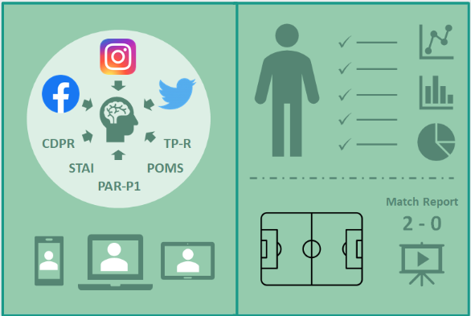

## Price

Choosing a proper pricing strategy is vital to reach all the segments of our target customer. In our case, we decided to follow an approach consisting of a combination of feature-based pricing and pay-as-you-go pricing. In this way, we will have two plans, basic and pro, with a price of 100-200€ and 150-300€ per year respectively.

Basic plan will have the following features:

* Psychological scouting
* 1 Region

Pro plan’s features will be:

* Psychological scouting
* Advanced performance statistics
* 1 Region

For each additional region the teams want to take into account in their scouting, they will be charged with 50€, and for each scouted player, the price will be 2€.

Regarding the aspects taken into account for setting the price, we checked our competitors’s prices (pricing to meet competition) and set a lower price, in order to enter the market. Besides, we took into account the cost of unlimited use of Twitter and Facebook APIs to gather user data (cost-based pricing). Nonetheless, our price may be readjusted after our first year, as we will have more useful and richer information.

The expected average revenue from each team is around 2,300€ (yearly), which means around 1000 players will be scouted by each team, in 1 to 3 geographical areas.

## Place

Our product is, in essence, an application that serves as a container for the services we offer. This means that we have to take into account the most common digital platforms used to run applications, so we are aiming for the ones with the highest rate of popularity. These are Web Applications, and smart devices applications.

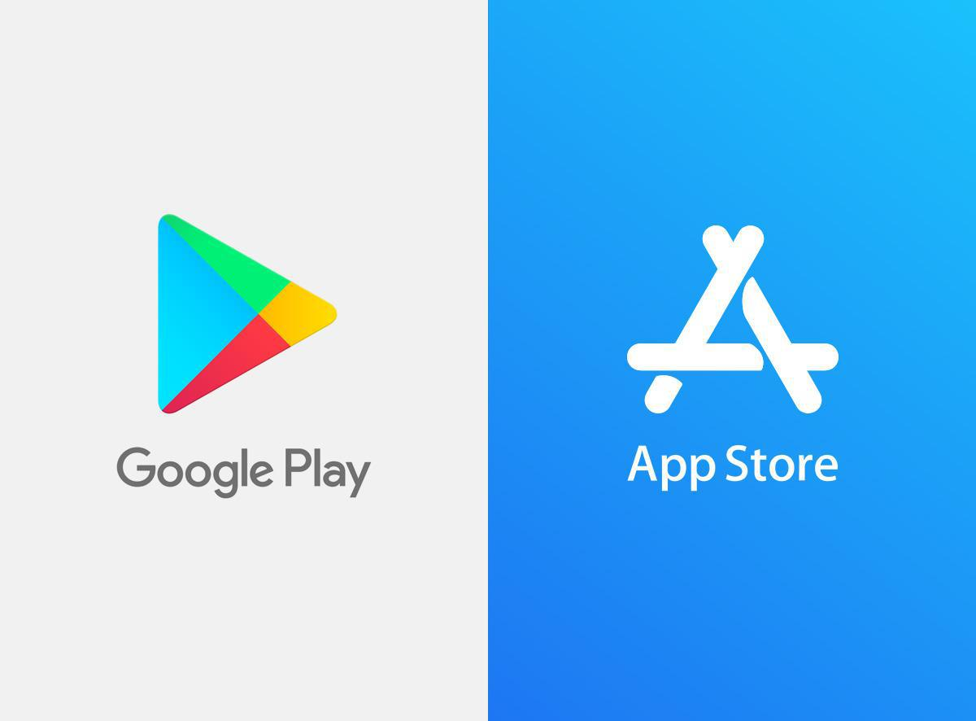

After considering the different possibilities, we decided to work with a hybrid framework. What this means is that we strived to design the application in a way that was convenient on development time, but didn’t narrow the reach of the possibilities of the final service. To do so, the idea is to create a responsive application that adapts the way it shows information to the user, but doesn’t change the information itself depending on the particular device. As a result, we can access the app via browser on a computer, or download the app for smart devices, with the only difference of having a better interface for the different screen sizes and interaction methods (mouse, touchscreen, etc.).

This raised the problem of having to decide the way in which we intend to offer our applications to Android or iPhone users. for this, it was very clear that we have to use (although maybe not exclusively) Google’s Play Store and Apple’s App Store. These are, without doubt, the most common and successful platforms for distributing mobile applications. They capture the vast majority of the market, and offer a sound way to offer your application to the massive public. This makes them the go-to option for virtually every developer team when it comes to launch their services, and introduce the problem of having to stand out among the thousands of applications placed there: we concluded that, if we wanted our company to be successful in a reasonable amount of time, and avoid the starvation the lack of awareness can produce, we started thinking in potential strategies, and complementary techniques. Our main objective then, is to be included in the top charts of the chosen stores, so we can increase the awareness of our company and product. To do so, we have to play with uncertainty, because we do not know how the algorithms of the store work, but we can focus on improving some statistics that are likely to be used by those algorithms. Number of downloads, and user rating are very important, so it is important to use techniques that give us an increase on one of them, or both.

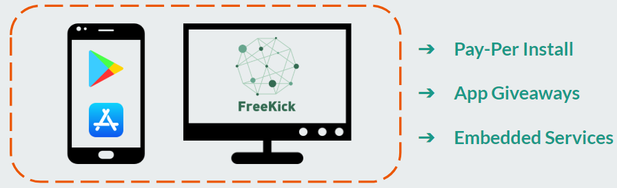

In certain platforms, there is the possibility of incentivizing the download. By offering a prize or gift when downloading the app, we can persuade more people to download the app. This is likely to increase the overall download count, but has the risk of creating a fake customer lock-in feeling: the users might download the app only for the gift, and not because they are really interested. We aim to create a solid user base, not to get a quick push that has no duration in time. For these reasons, such strategies have to be handled with care.

Other techniques include negotiating with the store, so they pay us in order to offer our app for free, with the condition of allowing them to include ads in our app. This can be helpful if the price of the app is a drawback for new users, but will damage the user experience to some extent. FInally, if we conclude that carving our own path is too costly and not worth the effort, we can consider including our services into another already existing, successful and popular product (potentially third-party) which is somehow complementary to our own, so at least we can have a certain success, and the users can enjoy our services.

## Promotion

As a newcomer to the scouting industry, gaining visibility and drawing clubs’ attention to our product and their uniqueness is capital for us. We will leverage social media features, with campaigns in social networks such as Facebook, Twitter or Instagram to attract amateur football players to our platform. Besides, we will communicate directly with football players and clubs in order for them to know our product.

Another important focus for our promotion approach will be physical events and campaigns. As we will collaborate with football teams, we can organize events altogether with those clubs in order for their fans to get to know our company, and potentially increase our number of users. This approach, while very suitable for our business, can face difficulties in case of unexpected events (v.g.: a global pandemic such as COVID-19). Given that situation, we have the possibility to focus on a virtual approach for our promotion campaigns. As soon as it is possible (and safe) to come back to a physical approach, we would organise again those events.

Collaboration with organizations such as FIFPRO [8] is also very important. These are football player organizations, and having a good relationship with them can make our platform to be considered as a beneficial tool for the players to be scouted by important teams.

# 

# Design: Products and Operations Plan

With a product as Freekick, several aspects need to be considered while the product development is ongoing, to make sure there’s a correct execution plan and enough resources invested to the corresponding tasks. In the following section we’ll go over the methodology for product development being followed, services we’re providing after launch, a detailed explanation of the components of the tool, and what improvements are on the pipeline for further releases.

## Situation of product/service and expected problems

Freekick, at the moment of launch, can be considered as an MVP (Minimum Viable Product). As defined by the Agile Alliance [9], MVP is a version of a new product which allows a team to collect the maximum amount of validated learning about customers with the least effort. The intention currently is to deploy the tool to the market so we can get feedback regarding the active modules and services from the customers. This means we would include basic functionality, to understand if this information is helpful enough and valuable, or we need to adjust and include other details which we didn’t have in mind within the plan. What would this basic functionality be?

* Psychological information from 2 or 3 of the tests currently in the scope.
* Sentiment analysis from social media from Twitter & Facebook.
* Basic searching criteria and filtering.
  + Country, League, Team and player Demographics
  + Psychological tests results
  + Sentiment grade from social media
* Statistical data from the players retrieved from open source repositories.

Though these are not small functionalities and they do require a high amount of development effort, there are greater features and information the application is capable of providing. This version will allow Freekick to enter the market and get valuable information from the customers to answer questions like:

* Are those psychological exams relevant?
* Does the application require more filtering capabilities?
* Is more information the only thing that would improve the product?
* Is the user interface friendly enough for the users?
* Are we in line with all GDPR regulations?
* Are we able to handle the traffic of the user requests?

With the deployment of such a version, problems can arise that will require attention to be resolved. Expected ones are related to network traffic and minor application bugs. If such problems become more complex, they will need to be resolved with a deployment of a new app version, as extensive testing needs to be done.

## Future designs

As the product footprint continues to grow, more features and capabilities will be implemented to improve the customer’s experience. Such capabilities could include:

* Better analytics related to the player statistics.
* Further player searching capabilities.
* Recommendations related to the user’s activity.
* Player profile comparison.

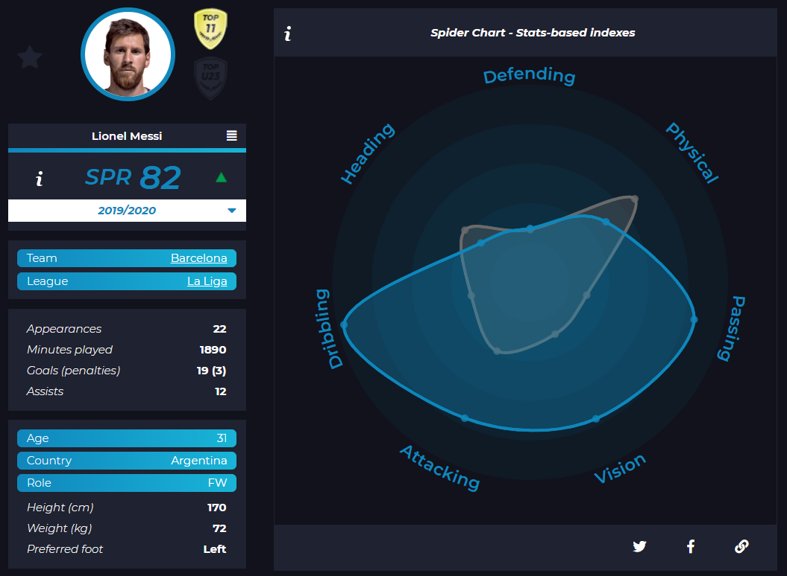

Source[10]: Soccerment Lionel Messi player analytics

The intention is to create a more complete scouting application overall, while still focusing on including as much information from different sources. The configuration of the psychological tests will require a big amount of effort, while also making sure that we have all adequate agreements with those organizations which have developed them. For those reasons, the introduction of new tests becomes a high effort task. Such improvements will be deployed in different releases to give an opportunity to the users to familiarize with the features and come up with feedback to improve them. It’s important that such future designs are co-related to the goal of enhancing the psychological information of the players. Therefore, high priority releases are gonna be focused on including more psychological exams. In order to not invest as much resources on the development of these new analytics, we will evaluate the option of outsourcing the analytics from a 3rd party. This will allow us to focus on marketing tasks related both to new customers or more psychological tests.

## Development budget per product line

Rather than defining a specific number of budget allocation for the application, we rather want to define a percentage of the revenues that will be allocated for research and development. The development of new analytics and retrieval of new sources of information is critical to expand our application and provide a better and more complete solution to our customers. Therefore we decided that around 10% of the company’s revenues should be allocated to R&D. Looking at the report of the OECD [11], it appears that organizations per country invest somewhere around 10% of their budget in 2009 and in most cases it has been an increase from what they allocated in the previous 15 years. A table which displays such comparison of investment can be seen below.

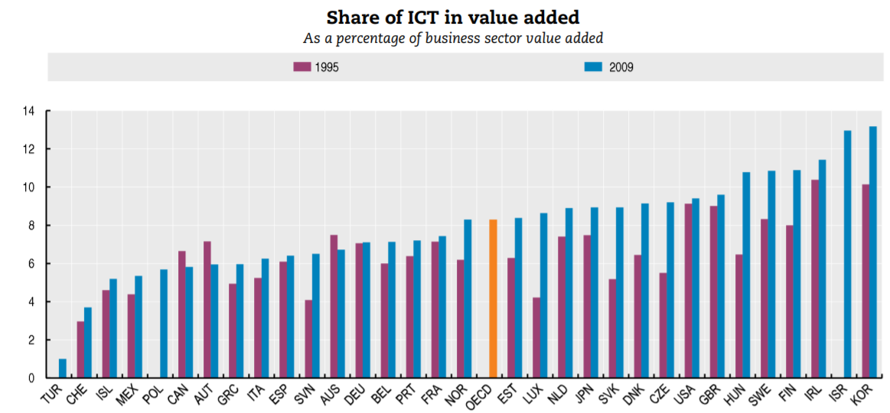

Source[11]: OECD share of information and communication technologies expenditure in R&D

Such percentage may eventually increase if needed or decreased if other departments or activities with a higher priority at the moment require more budget. Because the application will have an enough and stable source of information, if such a budget is not used within the month or so, the company can still continue its normal daily operations.

## Geographical location of the productive activities

There’s no real requirement for the company members to be co-located in the same place, but in order for the start-up to work with an agile methodology and enable a better development environment, we decided to locate our offices at Berlin. As one of the biggest start-up cities in Europe, we believe it is a great place for starting our operations. It will also allow us to collaborate with other start-ups located in the city, and have a centralized location from where we can reach several new potential customers. Besides our IT equipment (laptops, desks, etc.), there’s no further assets which we need to have in a specific geographic location. Therefore we will rent an office space from which the operation of the company will continue.

## Installations, description and technical features

Freekick has a complex architecture related to the Big Data environment. The product extracts data from different sources, stores them and processes them with transformations that are related to Apache Spark jobs and Natural Language Processing (NLP) jobs developed by Stanford University. After such transformations, the data is ready to be consumed by in-house developed analytics and presented within the UI.

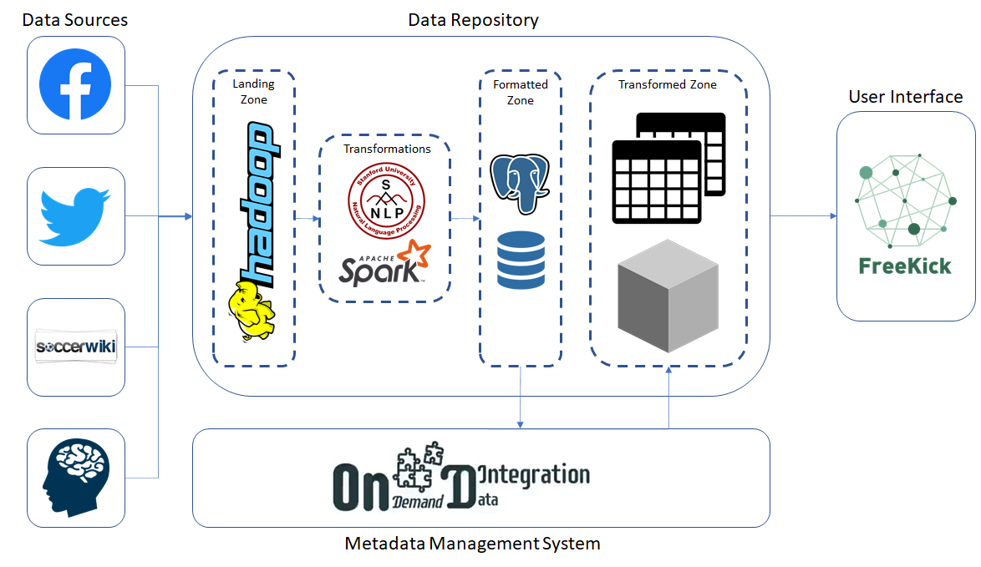

## Production strategy

The methodology for the application development that we intend to follow is Scrum. As described in the Scrum Methodology paper [12], agile processes use empirical, adaptive processes for rendering emerging requirements into a working system. This approach goes in line with our development strategy to release new features and requirements as fast as possible. The scrum methodology requires different components for it to work properly.

* **Sprint**: the work duration that results in an increment of the product functionality. In our case sprints would be of 3 weeks.
* **Daily Scrum**: the daily meeting where the status of each of the tasks is discussed and issues or blocks, if any, are resolved.
* **Product Backlog**: prioritized features list containing every desired feature or change to the product.
* **Sprint Backlog**: features selected from the product backlog to be worked within the sprint.
* **Scrum Team**: set of developers who work during the sprint duration on an increment.
* **Product Owner**: project’s key stakeholder and responsible to maximize value of the product for the customers. In our case the product owner would be the marketing lead.
* **Scrum Master**: helps the team use the Scrum process, by removing impediments to progress, by protecting the team from outside, and so on. In our case the scrum master would be the lead of the design and development team.

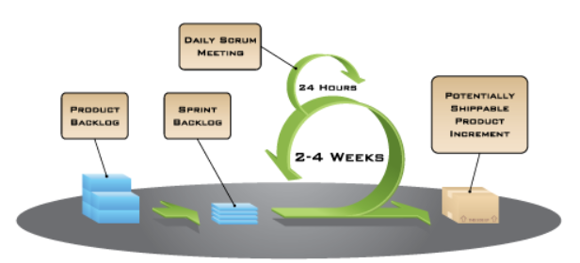

Source[13]: Mountain Goat Software scrum overview

There are several other meetings, like the sprint planning meeting, sprint review meeting, sprint retrospective meeting, and so on. Those will be held correspondingly on the dates of the Scrum lifecycle.

## Prototype

The main screens within our application are two, the search screen and the player profile. Below shown a prototype of what the search screen would look like…

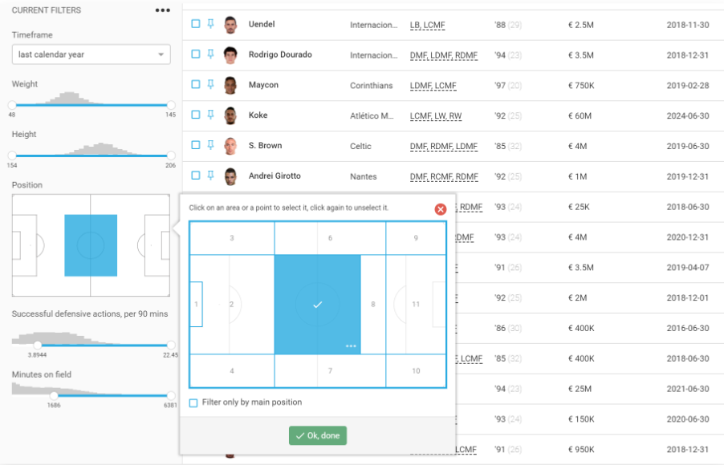

Source[14]: Wyscout Advanced Search screen

This screen will give the users the ability to search for very specific players based on different criteria:

* Country/division/team in which they’re currently playing.
* Position.
* Results on the psychological tests.
* Feedback from social media analysis.
* Player demographics.

After you’ve selected one of the players on the database, following screen would show their details:

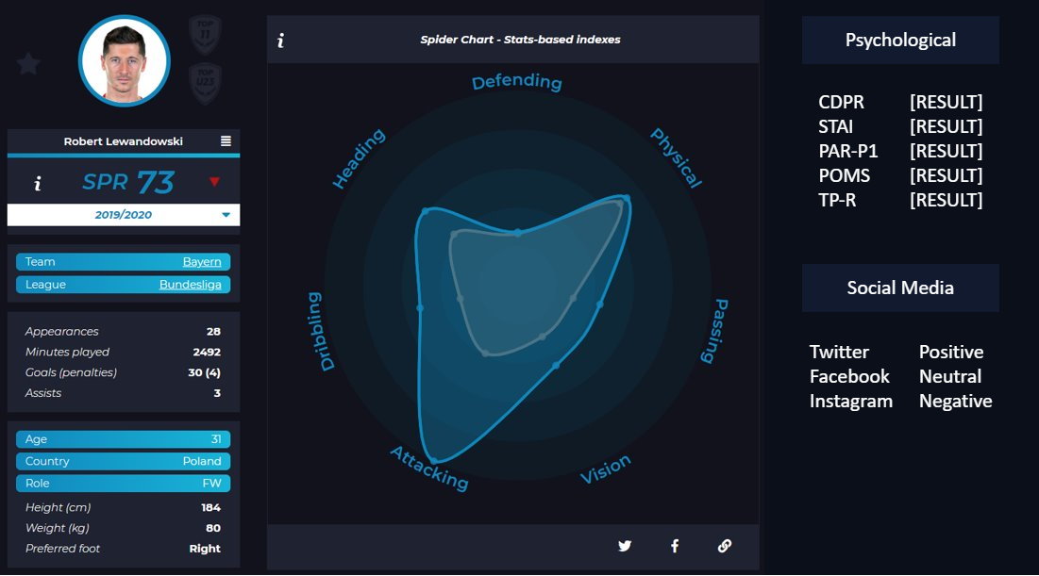

Source[15]: Soccerment Robert Lewandowski player analytics

Within the profile, demographic information of the player and basic analytics regarding their traits and skills will be displayed. On the right side, which is the most important section, the results from their psychological tests and social media analysis are shown. Such results will have a hyperlink attached to give an explanation of what the exam is analyzing and how to interpret the scores. As the product evolves, such sections will be adjusted to focus more on the psychological results and analysis, with optional screens to see other analytics related to performance. For our application, customer’s feedback is critical for adjusting the design of the user interface. Therefore we will include a “Feedback” button which will be active in all screens, for the users to give any comments and good or bad reviews over the functionalities of that section.

# Management Team and Staff Structure

In this section, several aspects regarding the composition of our team, as well as the tasks that each one will be focused on will be discussed. This means not only describing who will do what, but also specifying which endeavours are out of our reach and, therefore, we should rely on external professionals to manage them.

When it comes to a startup company, it is common for the entrepreneurs to do as much as they can and share different roles, as they know better than anyone about the company goals and how to work towards it. Thus, in this section it will be described how Freekick will be structured in terms of the human team, regarding their positions and backgrounds, compensation, and which are those tasks that will be outsourced.

## Organization: chart and profiles

As it has been stated, all the team members are expected to do whatever is necessary in every section. Nonetheless, some level of division of labour is needed. In this way, there will be four main sections in the company, namely:

* CEO: Freekick CEO will be Andrea Armani. He will be in charge of making the main corporate decisions, and will also be the public face of Freekick.
* Design and development: Everything related to creating the platform, maintaining it and adding features. This department will be led by Dimitrios Tsesmelis and Adrián Manco.
* Marketing: Marketing is an essential area in our business. We need to be known by players and football clubs, and this department will be in charge of it. The head of this section will be our CEO, Andrea Armani.
* Admin and HR: We need to devote one area to General Management, in order to follow our business plan and act accordingly if our situation changes. In the same way, we need to focus on Human Resources in order to guarantee the proper functioning of our human team. Ricardo Holthausen will lead this department.
* Finance: This is the department in charge of managing all the economical and fiscal aspects of our business. Jesús Huete will be the head of this department. It is noteworthy that most of the tasks related to this department will be done by our finance assistant. More details regarding this are given in the Professional support services to hire section.

An organizational chart is available below, and depicts the overall structure of our startup company.

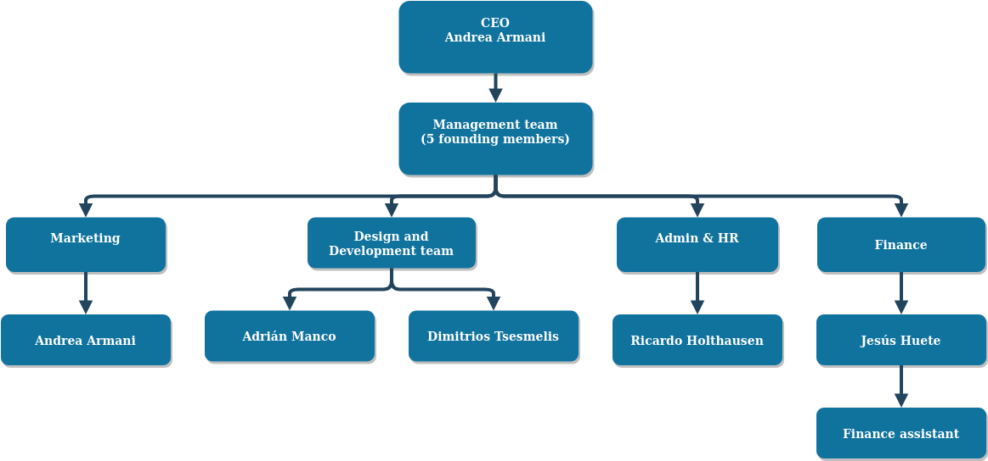

## Key directors: profiles and CVs

Our group of key directors is composed by five people. In this section, a brief description of their profiles and background is provided, as well as the reason they were assigned to each of the departments.

* **Dimitrios Tsesmelis, Greece**

Regarding his academical background, Dimitrios holds a Bachelor’s degree in Computer Science and telecommunication from National and Technical University of Athens. In addition, he is currently studying for a two years Master’s degree in Big Data Management and Analytics. Regarding his professional background, he worked as Application Development Associate in Accenture Greece for one year, assigned to a Data Warehouse Project for a leading Greek bank.

His areas of expertise are Data Management, especially Extract Transform Loading (ETL) processes and Data Warehousing. Besides, he has also experience working with Data Mining and Machine Learning models and processes, as well as with regards to Application Development.

Dimitrios will be, altogether with Adrián Manco, in charge of the Design and Development team. The main reason behind this is his experience on Application Development and Data Management, as it will be useful regarding the development of the platform and managing the data infrastructure for our product, respectively.

* **Adrián Manco, Spain**  
  Adrian’s background is Computer Science, Computer Networks and Distributed Systems. He did a bachelor degree in Computer Engineering, and specialized in Information Technology.  
  He also has working experience with Information Technology, Computer Network, as well as with Data Integration.

He will be head of the Design and Development team with Dimitrios, in order to leverage his Data Integration skills, as we have to deal with semantic data coming from several, distinct sources.

* **Jesús Huete, Mexico**  
  Jesus holds a Bachelor’s degree in Business Informatics from the Instituto Tecnológico y de Estudios Superiores de Monterrey. He also has a graduate certificate in Business Management from Indiana University and is currently studying for a two year Master’s degree in Big Data Management and Analytics.   
    
  He worked for 4 and a half years at General Electric, with different roles starting from an internship with the Sourcing Business Intelligence team of GE Transportation, to a Digital Technology Leadership Program. During his last year and a half at the company, he worked within the Supply Chain DT team for GE Power, where he led the implementation of different software at GE Power factories.

Although the main areas of expertise of this member are related to Business Intelligence and Application Development, he has worked previously in the Finance IT department of General Electric. He has an excellent understanding of the financial reports which the company has to submit, as well as a good understanding on how to manage budgets and cash flow.

* **Andrea Armani, Italy**  
  His academic background is mainly in Data Science and Computer Science. He integrated his studies with different courses related to finance and company's organization.   
    
  In his previous working experience he was first employed in the IT department of a marketing firm. During this experience, he had the opportunity to organize events for customers and work in different marketing campaigns. Then he participated in the creation of a startup, working there as Data Manager and Web Developer, learning how to build and structure the IT side of a new company.

Such experience in a startup qualifies Andrea as the CEO of our company. Additionally, his background makes him a good fit to be in charge of the marketing department within Freekick.

* **Ricardo Holthausen, Spain**  
  Ricardo did two Bachelor’s degrees on Psychology and Computer Science. He is currently enrolled in a Big Data Management and Analytics Master’s Degree, with specialization in Large Scale Data Analytics.

Similarly to the rest of members, Ricardo’s experience is related to Software Development and Data Management/Data Science. However, his academic background includes psychology, which allows him to be in charge of the Administration and Human Resources department.

## Directors’ shares: Remuneration and Contribution

As stated in the financial plan below, the five founding members will receive a gross salary of 30,000€ per year. This remuneration was set according to the economic capabilities of the company, as during the first year our revenues would not allow us to allocate a larger quantity to this element.

Regarding the members’ shares and contribution, it will be equally divided between the five directors. All of them will contribute to the company’s equity with 20,000€.

## Board of directors

We will not rely on external investors in order to create Freekick, therefore, there will not be any Board of Directors. In its place, there will be a CEO (Andrea Armani), which will make the main decisions of the company altogether with the Management Team (composed by the five founding members of Freekick).

## Professional support services to hire

As previously stated, there are some activities for which Freekick will need to hire external professionals. The main area for which this is needed is the financial/economic section of the company. Given the background of the Freekick founders, which is rather technical, our company will need support for all the accounting issues. This expenditure is considered in our financial plan.

Regarding other areas such as HR, PR, or even with regards to design and development, we are not considering any recruitment during the first year. Nonetheless, it actually depends on the adoption and success of our product. If it was the case, Freekick would increase the complexity of the organizational chart by adding these departments and recruiting more staff.

# 

# Business Project: Beginning Calendar

Freekick is a newly developed software, so it’s reasonable to think that, especially in the beginning of the startup, we will revise it often to optimize the product and provide the best user experience to our customers. In this early stage of the startup we are going to invite customers to provide feedback and suggestions to enrich and optimize our product. Once a sufficient number of feedback is collected, we will release an alpha and beta version of the tool and we are going to test it with a few customers.

Furthermore, throughout the year we will monitor the marketing campaign to check whether the expenses are adequate or should be reassessed. The usage of such measurements along with a record of the subscriptions will help us to respond to different company’s needs, such as a new workforce or a necessity of an additional investment. One desirable characteristic of Freekick is the flexible environment: although every person has a specific role in the company, we want to have the possibility to reassign the workforce based on specific needs of the company and the worker’s preferences and expertise. In order to achieve it, we designed a flexible meeting and revision schedule that will be explained further in this chapter. Finally, one of the most important tasks is to monitor the market. We are interested in analyzing how our competitors react to our entrance in the market, specifically we will control whether they will change their offer and their marketing strategy in order to limit our growth. This will suggest to us how we should rethink our product.

Freekick’s schedule will follow a Scrum methodology, which entails fast daily meetings along with a bigger one at the end of each Sprint. Furthermore, we schedule extensive meetings to discuss the overall strategy we are following and all points previously discussed in this chapter. Such meetings will happen at the end of every trimester. The ultimate goal is to build a highly responsive product that adapts to the customer’s requests.

# 

# Financial Plan

## Profit and Loss Statement Forecast

In this chapter we are going to present the profit and loss statement forecast of Freekick for the first 2 years of existence. To begin with, we first need to define the list of goods or services that we have to invest on. They can be splitted into two main categories, namely One-off investment and Expenses committed on an annual basis.

**One-off investment**

Below are the expenses that Freekick has to pay one time only, during the first year. This category includes the following goods/services along with their cost.

|  |  |
| --- | --- |
| **Cost description** | **Cost** |
| Five computers | 7,500.00 € |
| Mobile phones and other small devices | 2,500.00 € |
| Furniture and other small things for the office | 4,800.00 € |
| Deposit to be able to rent the office | 1,400.00 € |
| Notary, lawyers, deed of incorporation and other initial taxes | 2,500.00 € |
| Initial branding and communication expenses | 8,500.00 € |
| **Total Cost** | **27,200.00 €** |

**Annual expenses**

Below are the expenses that Freekick has to commit on an annual basis. This category includes the following goods/services along with its cost.

|  |  |
| --- | --- |
| **Cost description** | **Cost** |
| Cloud infrastructure | 1,000.00 € |
| Annual office rent | 8,400.00 € |
| Insurances | 2,500.00 € |
| Annual marketing expenses | 10,000.00 € |
| Salaries | 170,000.00 € |
| Twitter/Facebook API licenses | 24,000.00 € |
| **Total Cost** | **215,900.00 €** |

Cost explanation:

* Freekick will not maintain on-premises servers to host its services. **Cloud infrastructure** will be used instead.
* The cost of **Salaries** includes social security and it is calculated for 5 people with an annual average salary of 30,000 € plus an accountant with a salary around 20,000 €.

By using the previous number, we can create the Profit and Loss forecast of the first year and the Balance sheets for the first two years.

**Profit and Loss for year 1**

|  |  |
| --- | --- |
| Sales | 230,000.00 € |
| Cost of Services Sold | 24,000.00 € |
| **Gross Margin** | 206,000.00 € |

The above numbers arise from the sales forecast that we explained in detail in the sales prediction chapter. Assuming that for the first year the amount of customers is equal to 100 with an average sales per customer equal to 2,300 €, the forecasted income from sales is around **230,000.00 €.**

The Cost of our Services is calculated by the cost of the licences for Facebook and Twitter APIs which is equal to 1,000 € per month, times 12, which makes **24,000 €** per year.

|  |  |
| --- | --- |
| G&A Expenses | 191,900.00 € |
| Amortizations | 5,160.00 € |
| **Total G&A** | 197,060.00 € |
| **Operational Margin** | 8,940.00 € |

G&A Expenses are calculated by summing all the annual expenses, without taking into account the expenses related to Cost of Services Sold.

Amortization is the process of writing off the initial cost of an asset. In our financial plan, amortizations are calculated by summing all one-off investments times 20%, without taking into account the Rent Deposit as it is an amount that will be returned to the company later.

Finally, Operational Margin is the difference between Gross Margin minus Total G&A.

|  |  |
| --- | --- |
| Financial Expenses | 2,837.00 € |

To cover the expenses of the first year, we are planning to receive a Bank Financing , most probably a Working Capital Loan. The loan capital will be equal to **56,740.00 €** and we will progressively pay it off in five years (one installment at the end of each first year). We also assume that the loan interest will be around **5%** which makes a total interest of **2,837.00 €.** This amount is equal to the Financial Expenses that Freekick has to pay.

|  |  |
| --- | --- |
| Profit Before Tax | 6,103.00 € |
| Tax | 1,525.75 € |
| **Net Profit** | 4,577.25 € |

Profit Before Tax is the difference between the Operational Margin and the Financial Expenses. The tax is calculated as 25% of the Profit Before Tax and Net Profit is defined as the Profit Before Tax minus the Tax.

|  |  |
| --- | --- |
| **Pro Memoria** | |
| **Gross Cash Flow** | **11,263.00 €** |
| **Net Cash Flow** | **9,737.25 €** |
| **EBITDA** | **14,100.00 €** |

Gross Cash Flow is the sum of the Profit Before Taxes and the Amortizations. It gives an idea of the amount of money that the company is receiving, without taking into account taxes. If we want to take into account taxes, we use the Net Cash Flow. Regarding the EBITDA, it is the acronym for Earnings Before Interest, Taxes, Depreciation and Amortization. This indicator provides us with information about the profitability of our company.

## 

## 

## Balances Sheet Forecast

From the previous figures we can derive the following Balance Sheet Forecast for the first two years.

|  |  |  |  |
| --- | --- | --- | --- |
| **Balance Sheet of Year 1** | | | |
|
| **Fixed Assets** | 27,200.00 € | **Equity** | 100,000.00 € |
| **Current Assets** | - | **LT Liabilities** | 45,392.00 € |
| **Treasury** | 129,540.00 € | **ST Liabilities** | 11,348.00 € |
| **Total Balance** | **156,740.00 €** |  | **156,740.00 €** |
|  | | | |
|
| **Balance Sheet of Year 2** | | | |
|
| **Fixed Assets** | 22,040.00 € | **Equity** | 104,577.25 € |
| **Current Assets** | - | **LT Liabilities** | 34,044.00 € |
| **Treasury** | 129,455.00 € | **ST Liabilities** | 11,348.00 € |
| **Total Balance** | **151,495.00 €** |  | **149,969.25 €** |

## 

## Treasury Forecast

|  |  |  |  |  |  |  |
| --- | --- | --- | --- | --- | --- | --- |
| **Treasury Plan (Month 1-6)** | | | | | | |
|
| **Months** | 1 | 2 | 3 | 4 | 5 | 6 |
|  | | | | | | |
| **Sales collections** | 0 | 0 | 0 | 20,000 | 50,000 | 50,000 |
| Other collections | 0 | 0 | 0 | 0 | 0 | 0 |
| Capital increase | 0 | 0 | 0 | 0 | 0 | 0 |
| Loans | 0 | 0 | 0 | 0 | 0 | 0 |
| Divestments | 0 | 0 | 0 | 0 | 0 | 0 |
| Other financial collections | 0 | 0 | 0 | 0 | 0 | 0 |
|  | | | | | | |
| **TOTAL COLLECTIONS** | 0 | 0 | 0 | 20,000 | 50,000 | 50,000 |
|  | | | | | | |
| **Operating payments** | 17,170 | 17,170 | 17,170 | 22,838 | 17,170 | 17,170 |
| Materials/Licenses | 2,000 | 2,000 | 2,000 | 2,000 | 2,000 | 2,000 |
| Wages | 14,170 | 14,170 | 14,170 | 14,170 | 14,170 | 14,170 |
| Taxes | 0 | 0 | 0 | 5,668 | 0 | 0 |
| Other | 1,000 | 1,000 | 1,000 | 1,000 | 1,000 | 1,000 |
|  | | | | | | |
| **Other financial payments** | 0 | 0 | 0 | 0 | 0 | 0 |
| Dividends | 0 | 0 | 0 | 0 | 0 | 0 |
| Loans pay back | 0 | 0 | 0 | 0 | 0 | 0 |
| Investments | 0 | 0 | 0 | 0 | 0 | 0 |
| Other expenses | 0 | 0 | 0 | 0 | 0 | 0 |
|  | | | | | | |
| **TOTAL PAYMENTS** | 17,170 | 17,170 | 17,170 | 22,838 | 17,170 | 17,170 |
|  | | | | | | |
| **INITIAL TREASURY BALANCE** | 129,540 | 112,370 | 95,200 | 78,030 | 75,192 | 108,022 |
|  | | | | | | |
| **FINAL TREASURY BALANCE** | 112,370 | 95,200 | 78,030 | 75,192 | 108,022 | 140,852 |

|  |  |  |  |  |  |  |
| --- | --- | --- | --- | --- | --- | --- |
| **Treasury Plan (Month 7-12)** | | | | | | |
|
| **Months** | 7 | 8 | 9 | 10 | 11 | 12 |
|  | | | | | | |
| **Sales collections** | 20,000 | 25,000 | 5,000 | 5,000 | 20,000 | 35,000 |
| Other collections | 0 | 0 | 0 | 0 | 0 | 0 |
| Capital increase | 0 | 0 | 0 | 0 | 0 | 0 |
| Loans | 0 | 0 | 0 | 0 | 0 | 0 |
| Divestments | 0 | 0 | 0 | 0 | 0 | 0 |
| Other financial collections | 0 | 0 | 0 | 0 | 0 | 0 |
|  | | | | | | |
| **TOTAL COLLECTIONS** | 20,000 | 25,000 | 5,000 | 5,000 | 20,000 | 35,000 |
|  | | | | | | |
| **Operating payments** | 17,170 | 22,838 | 17,170 | 17,170 | 17,170 | 22,838 |
| Materials/Licenses | 2,000 | 2,000 | 2,000 | 2,000 | 2,000 | 2,000 |
| Wages | 14,170 | 14,170 | 14,170 | 14,170 | 14,170 | 14,170 |
| Taxes | 0 | 5,668 | 0 | 0 | 0 | 5,668 |
| Other | 1,000 | 1,000 | 1,000 | 1,000 | 1,000 | 1,000 |
|  | | | | | | |
| **Other financial payments** | 0 | 0 | 0 | 0 | 0 | 11,915.4 |
| Dividends | 0 | 0 | 0 | 0 | 0 | 0 |
| Loans pay back | 0 | 0 | 0 | 0 | 0 | 11,915.4 |
| Investments | 0 | 0 | 0 | 0 | 0 | 0 |
| Other expenses | 0 | 0 | 0 | 0 | 0 | 0 |
|  | | | | | | |
| **TOTAL PAYMENTS** | 17,170 | 22,838 | 17,170 | 17,170 | 17,170 | 34,753.4 |
|  | | | | | | |
| **INITIAL TREASURY BALANCE** | 140,852 | 143,682 | 145,844 | 133,674 | 121,504 | 124,334 |
|  | | | | | | |
| **FINAL TREASURY BALANCE** | 143,682 | 145,844 | 133,674 | 121,504 | 124,334 | 124,580.6 |

In the tables above it is depicted the Treasury Plan of Freekick for the first twelve month of existence. At this moment, we would like to explain a couple of assumptions that we made. First of all, we assume that the first three months will be the development phase of our product, which means that during this period we will not sell any service to our customers. In the next nine months, we assume that our sales will be up to 230,000€, which is equal to the amount of forecasted sales that we previously explained. This total number of sales is progressively distributed over the nine months. We also predict here that the peak of sales will be in May and June, as this the transfer period for football.

Regarding the Operating payments, we include the Materials that we need per month as well as the Facebook and Twitter Licenses that should be paid on a monthly basis. Moreover, we need to pay the salaries, the tax and we assume that we may have some additional expenses of around 1,000€. Regarding the Taxes that we have to commit to the government, we assume that we will pay them at the end of each quarter, as that is usually the case for tax payment and that the tax is equal to the 10% of the salaries of the employees.

Regarding the Other financial payments, we are taking into consideration that at the end of the year, we need to pay the first installment of the loan. This installment is equal to the total amount of the loan divided by 5 (years), plus the amount of the interest divided by 5. This makes a total of 11,915.4€.

Finally, we calculate the Final Treasury Balance which is equal to the Initial Treasury Balance at the beginning of the month plus the Total Collections of the current month minus the Total Payments of the current month. For each month, the Initial Treasury Balance is equal to the Final Treasury Balance of the previous month.

## Break-even Analysis

Break Even Analysis in economics, business, and cost accounting refers to the point in which total cost and total revenue are equal. A break even point analysis is used to determine the number of units or dollars of revenue needed to cover total costs. To calculate the break-even point, we use the following formula:

**Break even quantity = Fixed costs / (Sales price per unit – Variable cost per unit)**,

where

* **Fixed costs** are costs that do not change with varying output
* **Sales price per unit** is the selling price (unit selling price) per unit
* **Variable cost per unit** is the variable costs incurred to create a unit

According to the previous calculations, our **Fixed costs** are equal to **215,900€** and they consist of the annual offices’ rent, the insurances, the annual marketing expenses, the salaries, the taxes, the licenses and the cloud infrastructure. Our Variable cost per unit is zero and our average Sales price per unit is equal to **2,300€**. Putting all these numbers together in the formula, we end up with a **Break even quantity** equal to **94**.

Therefore, given the fixed costs, variable costs, and selling price of scouting packages, Freekick would need to sell its services to 94 clients to break even.

### Graphical representation of the Break Even point

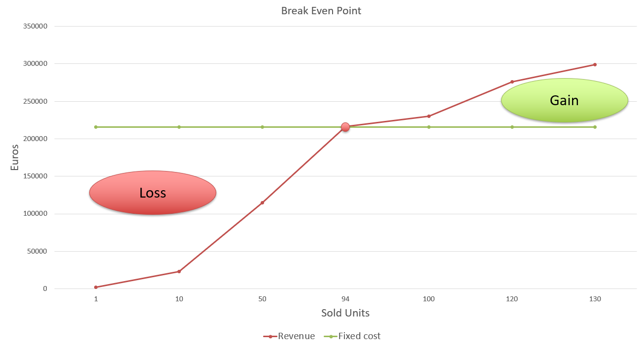

## 

## Cost Control Management

The Cost Control Management life cycle is depicted in the following diagram [16].

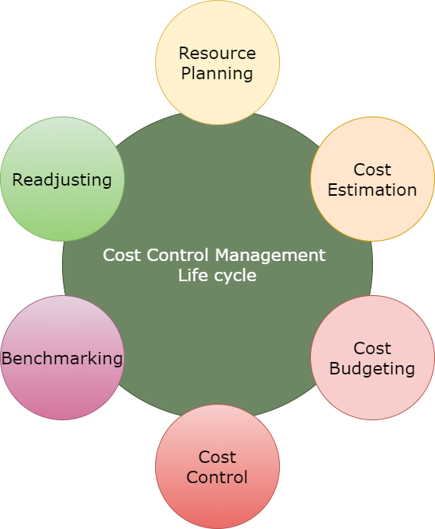

* **Resource planning** is the process of ascertaining future resource requirements for an organization or a scope of work. This process includes the definition of the required goods and services that Freekick will need to operate and were previously defined (e.g. computers, offices etc.).
* **Cost estimating** is the predictive process used to quantify, cost, and price the resources required by the scope of an investment option, activity, or project. To do an appropriate and accurate prediction, it is required to perform a market research to be sure that the estimated cost converges to the real one. During this step, we need to estimate the cost of the previously defined goods and services. For instance, in the case of five computers, we estimated that the total cost will be equal to 7,500€ as each professional laptop costs around 1,500€.
* Budgeting is a sub-process within estimating used for allocating the estimated cost of resources into cost accounts against which cost performance will be measured and assessed. This forms the baseline for cost control. **Cost control** is concerned with measuring variances from the cost baseline and taking effective corrective action to achieve minimum costs. For example, Freekick uses Cloud Computing and buys several licenses, the cost of which is pay-as-you-go. In such cases, we need to be very careful and control the cost on a monthly basis because Cloud Infrastructure can be very expensive if someone starts using it recklessly.
* Finally, as optional steps, we may introduce **Benchmarking** and **Readjusting**. These two processes are mainly used to increase the performance of future projects by learning from the mistakes of the past. In other words, whenever a cycle closes (e.g. the first year of a project is done or the whole project is done), benchmarking needs to be performed to illustrate the strengths and weaknesses of the Cost Control Management that has been done. In this way, the same mistakes will not be repeated and the total cost of the project will be minimized.

# 

# Business Plan: Potential Risks and Problems

As we have already mentioned, we firmly believe that Freekick is a startup company that is going to launch innovative products and services to the football market and hence it has the capabilities to become a prosperous business. But running a startup with good capabilities does not imply that you are not going to face risks and threats that should be carefully managed, otherwise they can be proven to be dangerous. Apart from the threats that we have already mentioned in a previous chapter, we will present some risks that we have found mostly related to the Financial part of the startup.

From the above Financial Plan, we can clearly spot two main threats. The first one is closely related to the very first days of Freekick as a startup. The core of our business is based on Information Technology (IT) and every IT project has an implementation phase, which varies from a few months to almost one year. Our estimation is that the time-to-market of Freekick will be three months, which implies that during the first three months, our sales will be zero. A serious problem that we may face at this point is the need of extension of the implementation period and this is not far from reality as it is difficult to estimate exactly how much time the implementation of a big IT project will take. In such a case, we will not have any income for more than three months.

We plan to tackle this problem using an Agile methodology, like Scrum [17]. By using such a methodology for the production of the code, we dramatically reduce the time-to-market, compared to a Waterfall methodology [18], as we are incrementally implementing the different components of our application and we can immediately deploy the one that is ready. Hence, we can always have a part of our product running and ready to be launched to the market. To further decrease the risk and take care of cases that it is impossible to deploy at least a first version of the product to the market during the first three months, apply to our Bank for an additional credit line of 30,000€ that we will be able to use at any time in order to cover the expenses of one to two months. Such extra credit amount may be used or not, depending on the overall solution development progress.

Another critical issue that we have identified from our Financial Plan is the significant sales downturn during September and October. More specifically, we can see that in September, we start with an Initial Treasury Balance of 145,844.00€ and in the end of the month it drops to 133,674.00€. Similarly, in October, the Balance drops from 133,674.00€ to 121,504.00€. This downturn during these months is caused by the fact that players transfers between football teams are mainly done during the summer months and hence, the scouting process pauses for the next few months. To be sure that we will not lack of liquid during these months, we need to save some money from the sales of May and June, where the Treasury Balance increased from 75,192.00€ to 108,022.00€ and from 108,022.00€ to 140,852.00€, respectively. In addition to that, during September and October, the development team will have the chance to solve any performance issues to the components that have already been deployed to the production as the workload will be pretty low.

Covid-19 global crisis is another factor that we indisputably need to think about. This is an external factor to our business but it can have a huge negative effect in our start-up. Football and in general most of the sports have been seriously affected by the pandemic during the last months as the matches, which are the main source of income for the teams, have been cancelled. In addition to that, the predictions show that the situation may not significantly change in the next few months so it would be rational to wait some time for it to get stable before starting a new startup like Freekick.

## 

# References

[1] European football market worth a record €25.5 billion as Premier League leads the way in new era of financial stability. Retrieved the 12th of June of 2020 from <https://www2.deloitte.com/uk/en/pages/press-releases/articles/annual-review-of-football-finance-2018.html>

[2] The European Club Footballing Landscape. Retrieved the 12th of June of 2020 from <https://it.uefa.com/MultimediaFiles/Download/OfficialDocument/uefaorg/Clublicensing/02/58/98/12/2589812_DOWNLOAD.pdf>

[3] Investopedia: Market value definition. Retrieved the 11th of June of 2020 from https://www.investopedia.com/terms/m/marketvalue.asp

[4] Football Teams Market Value. Retrieved the 11th of June of 2020 from <https://www.transfermarkt.com/>

[5] Professional Football Platform for Football Analysis: Wyscout. Retrieved the 11th of June of 2020 from <https://wyscout.com/>

[6] Wyscout Pricing System. Retrieved the 11th of June of 2020 from <https://wyscout.com/pricing/>

[7] The most accurate data & biggest player database: Instat Scout. Retrieved the 11th of June of 2020 from <https://instatsport.com/football>

[8] FIFPRO: Fédération Internationale des Associations de Footballeurs. Retrieved the 10th of June of 2020 from<https://www.fifpro.org/en>

[9] Agile Alliance: What is a Minimum Viable Product? Retrieved the 10th of June of 2020 from [https://www.agilealliance.org/glossary/mvp/](https://www.agilealliance.org/glossary/mvp/#q=~)

[10] Lionel Messi Stats. Retrieved the 10th of June of 2020 from <https://analytics.soccerment.com/en/stats/lionel-messi-1987-06-24>

[11] OECD: Expenditure on R&D. Retrieved the 10th of June of 2020 from <http://www.oecd.org/sdd/08_Science_and_technology.pdf>

[12] Scrum Methodology: Incremental, IterativeSoftware Development from Agile Processes. Retrieved the 10th of June of 2020 from <https://itq.ch/pdf/SCRUM_methodology.pdf>

[13] Scrum Overview for Agile Software Development. Retrieved the 10th of June of 2020 from <https://www.mountaingoatsoftware.com/agile/scrum/resources/overview#:~:text=Scrum%20is%20a%20project%20management,two%20to%20four%20weeks%20long>

[14] WyScout Advanced Search. Retrieved the 10th of June of 2020 from <https://wyscout.com/football-platform/advanced-search/>

[15] Robert Lewandowski Stats. Retrieved the 10th of June of 2020 from <https://analytics.soccerment.com/en/stats/robert-lewandowski-1988-08-21>

[16] Cost Control Management. Retrieved the 10th of June of 2020 from <https://www.costmanagement.eu/blog-article/198-cost-management-explained-in-4-steps>

[17] Scrum Methodology. Retrieved the 11th of June of 2020 from <https://www.scrum.org/resources/what-is-scrum>

[18] Waterfall Methodology. Retrieved the 11th of June of 2020 from <https://www.projectmanager.com/software/use-cases/waterfall-methodology>

# 

# Appendix A

## Table 1 (Customer segmentation)

|  |  |  |  |
| --- | --- | --- | --- |
| **League** | **Name** | **Total market value** | **Segmentation** |
| England | Manchester City | €1.29bn | Segment1 |
| England | Liverpool FC | €1.19bn | Segment1 |
| Spain | Real Madrid | €1,08bn | Segment1 |
| Spain | FC Barcelona | €1,07bn | Segment1 |
| France | Paris SG | €1.02bn | Segment1 |
| Germany | Bayern Munich | €934.15m | Segment1 |
| England | Tottenham Hotspur | €885.50m | Segment1 |
| Spain | Atlético Madrid | €863,50m | Segment1 |
| England | Chelsea FC | €848.05m | Segment1 |
| England | Manchester United | €800.75m | Segment1 |
| Italy | Juventus | €762.50m | Segment1 |
| England | Arsenal FC | €698.75m | Segment1 |
| Italy | SSC Napoli | €688.00m | Segment1 |
| Italy | Inter | €682.40m | Segment1 |
| Germany | Bor. Dortmund | €637.40m | Segment1 |
| Germany | RB Leipzig | €594.40m | Segment2 |
| Spain | Valencia | €529,50m | Segment2 |
| England | Leicester City | €501.25m | Segment2 |
| England | Everton FC | €475.70m | Segment2 |
| Germany | Bay. Leverkusen | €445.75m | Segment2 |
| Italy | AS Roma | €440.30m | Segment2 |
| Netherlands | Ajax Amsterdam | €433.40m | Segment2 |
| France | Olympique Lyon | €419.50m | Segment2 |
| Italy | AC Milan | €399.00m | Segment3 |
| England | West Ham United | €368.75m | Segment3 |
| Spain | Real Sociedad | €354,50m | Segment3 |
| England | Wolverhampton Wanderers | €344.55m | Segment3 |
| England | AFC Bournemouth | €342.75m | Segment3 |
| France | Monaco | €335.35m | Segment3 |
| Italy | Lazio | €325.65m | Segment3 |
| Germany | Bor. M'gladbach | €312.00m | Segment3 |
| England | Newcastle United | €311.33m | Segment3 |
| Italy | Fiorentina | €302.60m | Segment3 |
| Italy | Atalanta | €297.60m | Segment3 |
| Spain | Real Betis | €288,50m | Segment3 |
| Spain | Sevilla FC | €280,00m | Segment3 |
| France | LOSC Lille | €261.60m | Segment3 |
| England | Aston Villa | €261.40m | Segment3 |
| France | Marseille | €246.60m | Segment4 |
| Germany | FC Schalke 04 | €242.75m | Segment4 |
| Spain | Athletic | €241,00m | Segment4 |
| Germany | TSG Hoffenheim | €238.23m | Segment4 |
| Germany | Hertha BSC | €233.20m | Segment4 |
| England | Watford FC | €231.80m | Segment4 |
| Germany | VfL Wolfsburg | €230.95m | Segment4 |
| England | Crystal Palace | €230.00m | Segment4 |
| Spain | Villarreal | €228,40m | Segment4 |
| England | Brighton & Hove Albion | €227.25m | Segment4 |
| England | Southampton FC | €220.00m | Segment4 |
| Germany | E. Frankfurt | €215.80m | Segment4 |
| England | Burnley FC | €195.75m | Segment4 |
| Italy | Torino | €194.05m | Segment4 |
| Italy | Cagliari Calcio | €190.10m | Segment4 |
| Germany | Werder Bremen | €189.75m | Segment4 |
| France | Stade Rennais | €184.50m | Segment4 |
| France | OGC Nice | €184.40m | Segment4 |
| Spain | Celta de Vigo | €180,10m | Segment4 |
| Spain | Getafe | €177,60m | Segment4 |
| Netherlands | PSV Eindhoven | €165.00m | Segment4 |
| Spain | Espanyol | €163,20m | Segment4 |
| Italy | Sassuolo | €162.00m | Segment4 |
| Italy | Parma | €151.10m | Segment4 |
| Ukraine | Shakhtar Donetsk | €150.60m | Segment4 |
| Germany | 1.FSV Mainz 05 | €147.40m | Segment5 |
| Germany | SC Freiburg | €145.48m | Segment5 |
| England | Norwich City | €145.35m | Segment5 |
| England | Sheffield United | €142.85m | Segment5 |
| Italy | Sampdoria | €138.35m | Segment5 |
| Germany | FC Augsburg | €131.15m | Segment5 |
| France | G. Bordeaux | €131.00m | Segment5 |
| Italy | Genoa | €130.90m | Segment5 |
| Italy | Bologna | €130.13m | Segment5 |
| Italy | Udinese Calcio | €124.00m | Segment5 |
| France | Saint-Étienne | €123.20m | Segment5 |
| Netherlands | AZ Alkmaar | €121.80m | Segment5 |
| Spain | Alavés | €106,90m | Segment5 |
| Germany | 1. FC Köln | €102.20m | Segment5 |
| Spain | Levante | €101,30m | Segment5 |
| France | Montpellier | €97.05m | Segment5 |
| Italy | Hellas Verona | €96.68m | Segment5 |
| Germany | F. Düsseldorf | €93.10m | Segment5 |
| Spain | CD Leganés | €93,05m | Segment5 |
| France | Toulouse | €92.50m | Segment5 |
| France | FC Nantes | €92.15m | Segment5 |
| Italy | Brescia | €91.90m | Segment5 |
| France | R. Strasbourg | €90.75m | Segment5 |
| Ukraine | Dynamo Kyiv | €89.85m | Segment5 |
| Spain | Real Valladolid | €87,70m | Segment5 |
| Netherlands | Feyenoord Rotterdam | €87.33m | Segment5 |
| France | SCO Angers | €78.60m | Segment5 |
| France | Reims | €78.00m | Segment5 |
| Greece | Olympiacos | €73.80m | Segment5 |
| Italy | SPAL | €73.65m | Segment5 |
| Spain | RCD Mallorca | €73,40m | Segment5 |
| Spain | SD Eibar | €65,90m | Segment5 |
| Greece | PAOK Salonika | €65.00m | Segment5 |
| Spain | CA Osasuna | €63,60m | Segment5 |
| France | SC Amiens | €63.50m | Segment5 |
| Spain | Granada CF | €59,90m | Segment5 |
| France | Nîmes Olympique | €55.00m | Segment5 |
| France | Stade Brest 29 | €54.60m | Segment5 |
| Italy | Lecce | €53.65m | Segment5 |
| France | FC Metz | €53.00m | Segment5 |
| Netherlands | FC Utrecht | €49.40m | Segment6 |
| France | Dijon | €46.60m | Segment6 |
| Germany | Union Berlin | €43.05m | Segment6 |
| Greece | AEK Athens | €35.40m | Segment6 |
| Germany | SC Paderborn | €31.25m | Segment6 |
| Netherlands | Vitesse Arnhem | €25.95m | Segment6 |
| Netherlands | SC Heerenveen | €24.98m | Segment6 |
| Greece | Panathinaikos | €23.10m | Segment6 |
| Netherlands | FC Twente Enschede | €22.78m | Segment6 |
| Netherlands | Willem II Tilburg | €21.50m | Segment6 |
| Netherlands | Heracles Almelo | €21.25m | Segment6 |
| Netherlands | FC Groningen | €20.15m | Segment6 |
| Netherlands | ADO Den Haag | €18.73m | Segment6 |
| Ukraine | Zarya Lugansk | €17.60m | Segment6 |
| Netherlands | PEC Zwolle | €15.68m | Segment6 |
| Netherlands | FC Emmen | €15.13m | Segment6 |
| Netherlands | Sparta Rotterdam | €14.80m | Segment6 |
| Ukraine | FK Oleksandria | €14.35m | Segment6 |
| Netherlands | Fortuna Sittard | €13.60m | Segment6 |
| Greece | Atromitos Athen | €13.55m | Segment6 |
| Greece | AE Larisa | €12.78m | Segment6 |
| Greece | Aris Saloniki | €12.75m | Segment6 |
| Netherlands | VVV-Venlo | €12.45m | Segment6 |
| Ukraine | SK Dnipro-1 | €11.90m | Segment6 |
| Ukraine | Desna Chernihiv | €11.40m | Segment6 |
| Ukraine | FK Mariupol | €11.15m | Segment6 |
| Greece | OFI Crete | €11.10m | Segment6 |
| Netherlands | RKC Waalwijk | €10.68m | Segment6 |
| Greece | AO Xanthi | €10.60m | Segment6 |
| Ukraine | Vorskla Poltava | €10.43m | Segment6 |
| Greece | Asteras Tripoli | €9.98m | Segment6 |
| Ukraine | Olimpik Donetsk | €8.83m | Segment6 |
| Greece | Panetolikos | €8.35m | Segment6 |
| Greece | Volos NPS | €7.90m | Segment6 |
| Ukraine | Kolos Kovalivka | €7.90m | Segment6 |
| Greece | PAS Lamia | €7.40m | Segment6 |
| Greece | Panionios | €7.28m | Segment6 |
| Ukraine | FK Lviv | €6.63m | Segment6 |
| Ukraine | Karpaty Lviv | €5.95m | Segment6 |